Driven Racing Oil™ Releases SR50 Economical Race Oil Option
Huntersville, NC – The latest addition to the Driven Racing Oil™ line of lubricants was developed to provide maximum performance at a price the Sportsman Racer can afford.
SR50 20W-50 is a robust conventional motor oil to be used where frequent oil changes are needed, such as in dirt track and sportsman bracket racing, to eliminate the build-up of dirt or fuel dilution. It utilizes a proprietary anti-wear and friction-reducing additive package to fight valve train wear and internal scuffing.
Ideal for race engines requiring a 20W-50 weight motor oil, SR50 provides consistent protection for flat tappet engines and prevents lifter skidding in aggressive roller cam valve trains using both needle and bushing lifters. It is not recommended in engines with stamped steel rockers; instead, use Driven Racing Oil’s XP9 or XP6 for optimal durability.
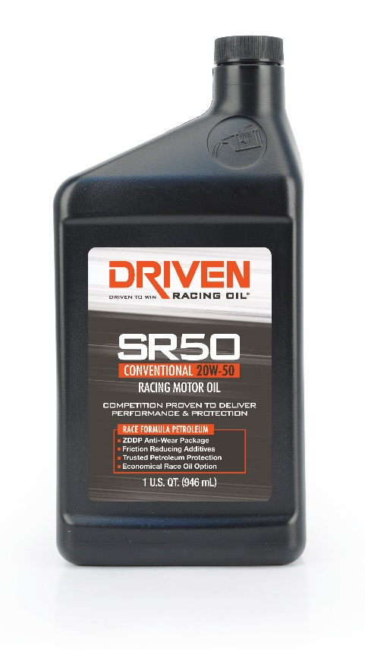
About Driven Racing Oil™
Born from Joe Gibbs Racing, one of the most successful NASCAR teams of the past two decades, Driven Racing Oil™ utilizes cutting-edge lubricant technology and on-track research for maximum performance gains from all of its product offerings. Competition drives innovation, and Joe Gibbs Racing originally developed the Driven brand of oils to advance engine and driveline performance on the racetrack. From full-synthetic race oils to engine break-in oils and cleaners, Driven offers a wide range of race and street products that deliver performance, protection and value.

